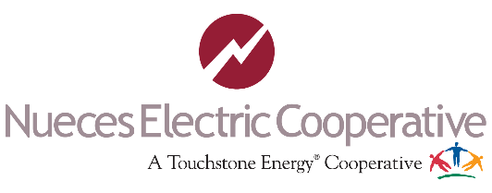
Agenda
3rd Annual Coastal Bend
Lineman Rodeo 4/14/2023

Breakfast @6:30am for participants & judges.

7:15am 7:30am

7:40am 7:50am
8:00am -
1:30pm

12:00pm -
2:00pm

2:30pm
Opening Prayer National Anthem
Stephanie Abriana is a local artist and has been singing and performing all her life. She made history at the famous Grande Ole Opry stage as the first person in the world to ever sing a Spanish song there. You can catch her around town with her band at local festivals and nightclubs.

Job Briefing (Journeyman Lineman) Registration & sign job briefing Lineman Rodeo
Apprentice Events
Transformer arrestor changeout
Hurt man rescue
Speed climb

Journeyman Event
Crossarm change out
Hurt man rescue
Speed climb

Lunch

Announce winners of rodeo.

**** All times are subject to change throughout the day.

****All participants are encouraged to inspect all tools and equipment prior to the rodeo.

For any questions or concerns feel free to contact me. Joe Huerta III, Email: jhuerta@nueceselectric.org or call 361-767-7308. Let us make this a SAFE and fun event! SAFETY ALWAYS!!

